**Axis IOCL CC**

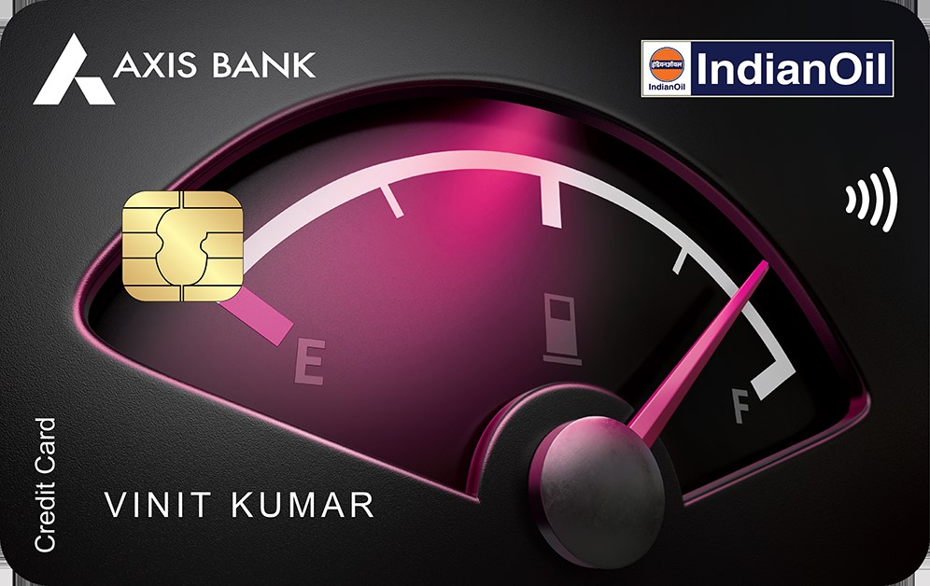

|  |  |
| --- | --- |
|  |  |

**Benefits of Axis Indian Oil Credit Card**

* 100% Cashback up to Rs 250 on first fuel transaction performed on your card in first 30 Days of card issuance.
* Enjoy 4% value back on Fuel Spends, 20 reward points per Rs 100 spent at IOCL pumps across India. Transact in India at IOCL fuel outlet between INR 100 and INR 5000 per month to avail the offer . Maximum eligible spends per statement: INR 5000. Only applicable for fuel MCC 5541
* 1% fuel surcharge waiver. Fuel spends in India at any fuel outlet between INR 200-INR 5000 to avail the offer. Max. waiver of INR 50 per statement cycle. GST charged on fuel surcharge is non-refundable. Only applicable for fuel MCC 5541
* Up to 10% instant discount on movie tickets via BookMyShow app or website. Each customer can get a maximum discount of Rs. 100 per month. The Offer is valid till 31st March 2024. For detailed T&C, visit: <https://www.axisbank.com/docs/default-source/default-document-library/indianoil-axis-bank-offer-t-c.pdf>.
* Up to 15% dining discounts at partner restaurants in India via EazyDiner. Offer details: 15% off upto Rs. 500 and minimum order value INR 2500. Valid once per card per month max benefits upto inr 500.
* 1% value back on online shopping by earning 5 rewards points per INR 100 spent. Transact at online merchants between INR 100 – INR 5000 to avail offer.
* Spend INR 50, 000 in a year to be eligible for Annual Fee waiver. Rent transactions, EMI transactions, Cash Withdrawals, fees, charges, GST, insurance spends wallet load transactions not eligible for this offer.
* Earn 1 EDGE REWARD point on INR 100 spend with your credit card.

**How to Apply for Axis Indian Oil Credit Card**

* User click on the CTA button and redirect to bank website
* User Click Login/Join Now and do OTP verification.
* User Select Axis Indian Oil Credit Card and provide the required details.
* User’s application will be submitted, and a confirmation SMS will be sent on approval of user’s application.
* User Get application status within 10 minutes.

**Documents required for the Application**

* PAN Card/Form 60
* ID Proof
* Address Proof
* Bank Statement
* Income Proof

**Eligibility Criteria**

* Employment status: Salaried or self-employed
* Salaried: Starting from Rs 21,000
* Self Employed: Starting from Rs 30,000
* Available across major cities in India
* Age: 21-60 years

**Fees and List of all Charges**

* Joining Fees: Rs 500 + GST
* Annual Fees: Lifetime Rs 500 + GST
* Interest Rate: 3.6% per month (49.36% per annum)
* Cash Withdrawal charges: 2.5% or Rs 500, whichever is higher
* Card Replacement charges: Nil

**Important Information**

* If user’s Card is disbursed, you will be eligible for commission
* No commission if Application is Rejected
* Cashback earned will be deducted from your next month credit card statement